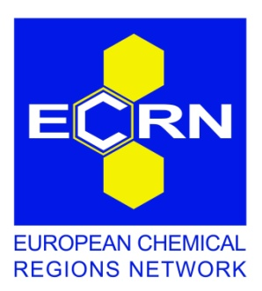

10th ECRN Congress, Warsaw, 5-6 December 2012
Registration form

Title: | Choose an item.
First Name: | Click here to enter text.
Last Name: | Click here to enter text.
Organisation: | Click here to enter text.
Position: | Click here to enter text.
Address: | Click here to enter text.
City: | Click here to enter text.
Postcode: | Click here to enter text.
Country: | Click here to enter text.
Tel.: | Click here to enter text.
E-mail: | Click here to enter text.
Website: | Click here to enter text.

I will attend:
Day 1: Opening session and panel discussion (5 December)
Day 2: Workshops and closing session (6 December)

Please indicate your preference for the parallel workshops (6 December):
9:15-10:45 Session 1: Innovation and clusters
Session 2: Resource and energy efficiency

11:15-12:45 Session 3: Chemical logistics
Session 4: Skills development and skills gaps in the chemical industry

For catering purposes, please indicate if you will attend:
Congress lunch (at 12:00) on 5 December
Congress reception (at 19:00) on 5 December
Congress lunch (at 14:00) on 6 December

Special dietary requirements (if any): Click here to enter text.

Will you be staying at the Congress hotel:
(Please note that participants are required to make their own reservations for accommodation.)
Yes No

Do you agree to have your contact details (name, organisation, e-mail) included in the list of participants:
Yes No

